**Log Shipping :-**

Log shipping is the process of automating the backup of transaction log files on a primary database server, and then restoring them onto a standby server.

Log shipping involves copying a database backup and subsequent transaction log backups from the primary (source) server and restoring the database and transaction log backups on one or more secondary (Stand By / Destination) servers. The Target Database is in a standby or no-recovery mode on the secondary server(s) which allows subsequent transaction logs to be backed up on the primary and shipped (or copied) to the secondary servers and then applied (restored) there.

Log Shipping Permissions

To setup a log-shipping you must have sysadmin rights on the server.

Log Shipping Minimum Requirements

1. SQL Server 2019
2. Standard, Workgroup or Enterprise editions must be installed on all server instances involved in log shipping.
3. The servers involved in log shipping should have the same case sensitivity settings.
4. The database must use the full recovery or bulk-logged recovery model
5. A shared folder for copying T-Log backup files
6. SQL Server Agent Service must be configured properly

**Steps to Configure SQL Server Log Shipping**

**Step 1**

Make sure your database is in full or bulk-logged recovery model. You can change the database recovery model using the below query. You can check the database recovery model by querying sys.databases

SELECT name, recovery_model_desc FROM sys.databases WHERE name = 'TendersDb'

USE [master]

ALTER DATABASE ['TendersDb'] SET RECOVERY FULL WITH NO_WAIT

GO

GO

**Step 2**

On the primary server, right click on the database in SSMS and select Properties. Then select the **Transaction Log Shipping** Page. Check the **"Enable this as primary database in a log shipping configuration"** check box.

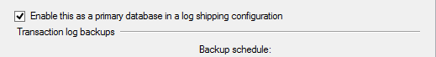

**Step 3**

The next step is to configure and schedule a transaction log backup. Click on **Backup Settings...** to do this.

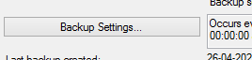

If you are creating backups on a network share enter the network path or for the local machine you can specify the local folder path. The backup compression feature was introduced in SQL Server 2019 edition. While configuring log shipping, we can control the backup compression behavior of log backups by specifying the compression option. When this step is completed it will create the backup job on the Primary Server.

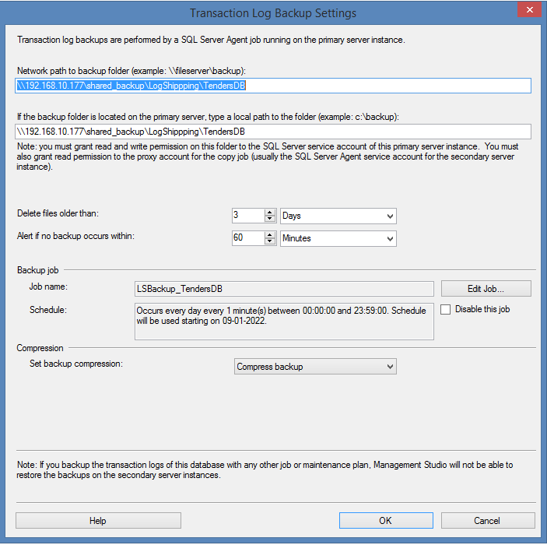

**Step 4**

In this step we will configure the secondary instance and database. Click on the **Add...** button to configure the Secondary Server instance and database. You can add multiple servers if you want to setup one to many server log-shipping.

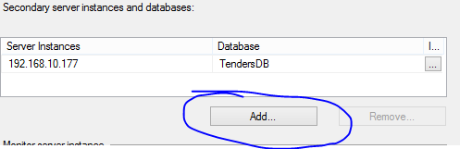

When you click the **Add...** button it will take you to the below screen where you have to configure the Secondary Server and database. Click on the **Connect...** button to connect to the secondary server. Once you connect to the secondary server you can access the three tabs as shown below.

**Initialize Secondary Database for Log Shipping on SQL Server**

In this step you can specify how to create the data on the secondary server. You have three options: create a backup and restore it, use an existing backup and restore or do nothing because you have manually restored the database and have put it into the correct state to receive additional backups.

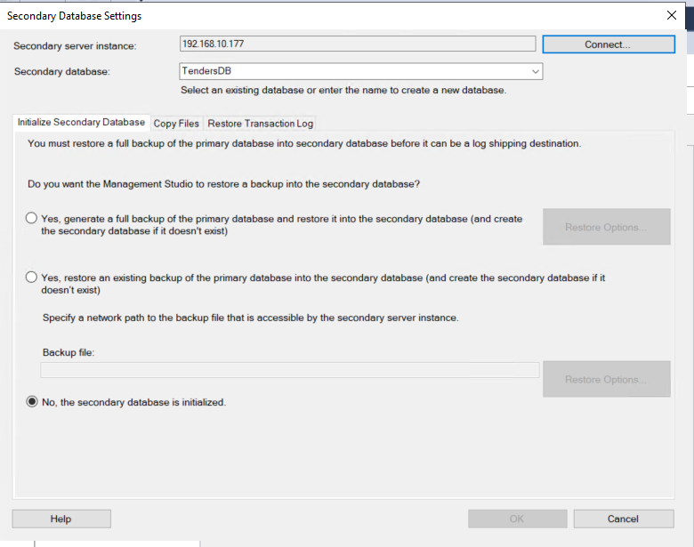

**Copy Files for Log Shipping for SQL Server**

In this tab you have to specify the path of the Destination Shared Folder where the Log Shipping Copy job will copy the T-Log backup files. This step will create the Copy job on the secondary server.

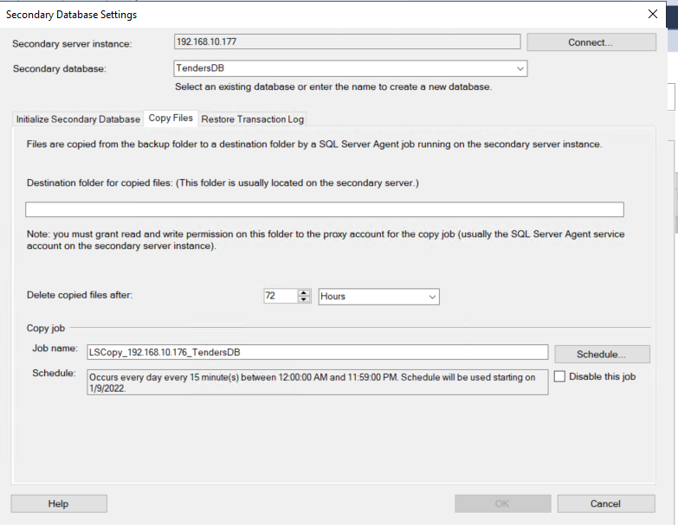

**Restore Transaction Log for SQL Server Log Shipping**

Here you have to specify the database restoring state information and restore schedule. This will create the restore job on the secondary server.

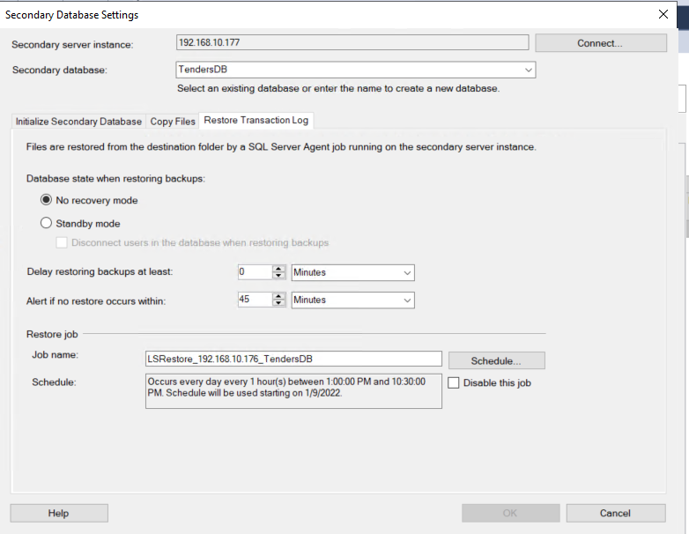

**Step 5**

In this step we will configure Log Shipping Monitoring which will notify us in case of any failure. Please note Log Shipping monitoring configuration is optional

.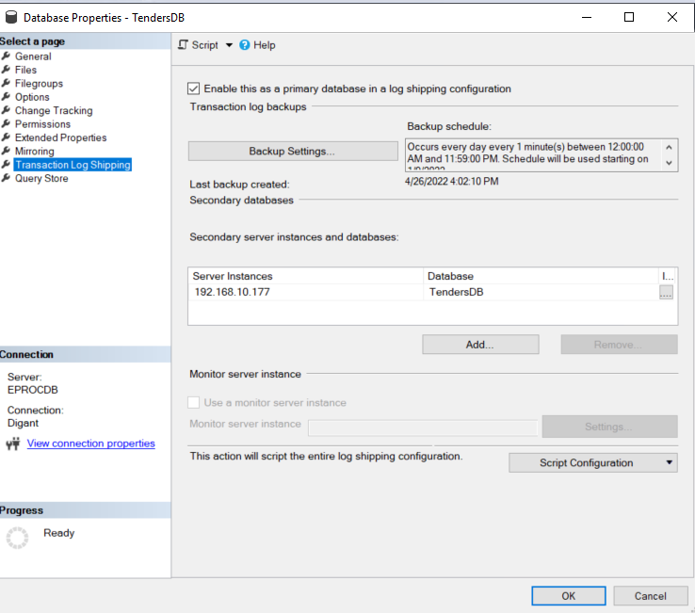

Click on **Settings...** button which will take you to the **"Log Shipping Monitor Settings"** screen. Click on **Connect ...** button to setup a monitor server. Monitoring can be done from the source server, target server or a separate SQL Server instance. We can configure alerts on source / destination server if respective jobs fail. Lastly we can also configure how long job history records are retained in the MSDB database. Please note that you cannot add a monitor instance once log shipping is configured.

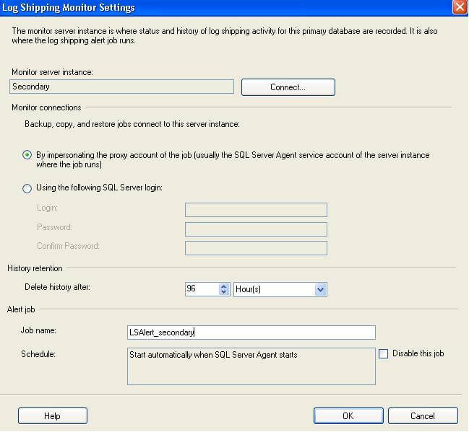

**Step 6**

Click on the **OK** button to finish the Log Shipping configuration and it will show you the below screen.

